Test Case: tc001_SPX_Dev5_Crear_Nueva_Linea_Requisicion_Spot_Tipo_Cobro_CC
Step 1 - Enter username and password and click to button Enter : Credentials Entered
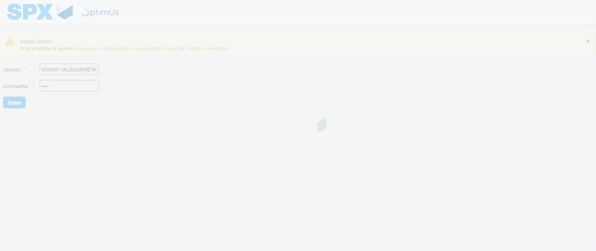Image file-name: QC_Testing-tc001_SPX_Dev5_Crear_Nueva_Linea_Requisicion_Spot_Tipo_Cobro_CC-1781565683307

Step 2 - Select to UEN and Access to Spot Buy Requisitions : UEN Correctly selected and Correct access
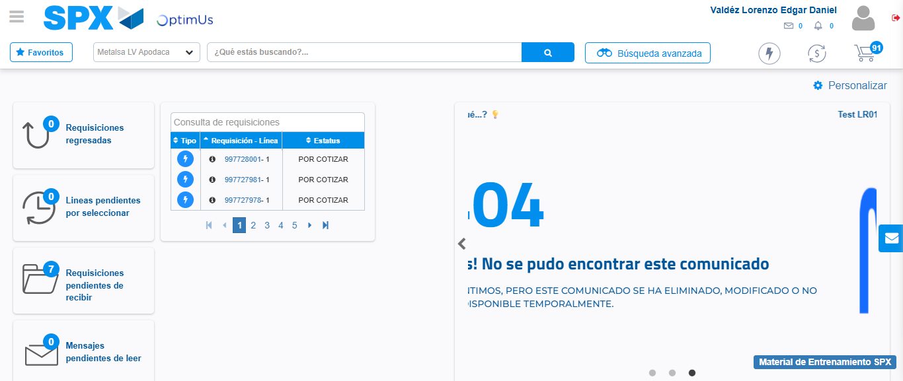Image file-name: QC_Testing-tc001_SPX_Dev5_Crear_Nueva_Linea_Requisicion_Spot_Tipo_Cobro_CC-1781565718483

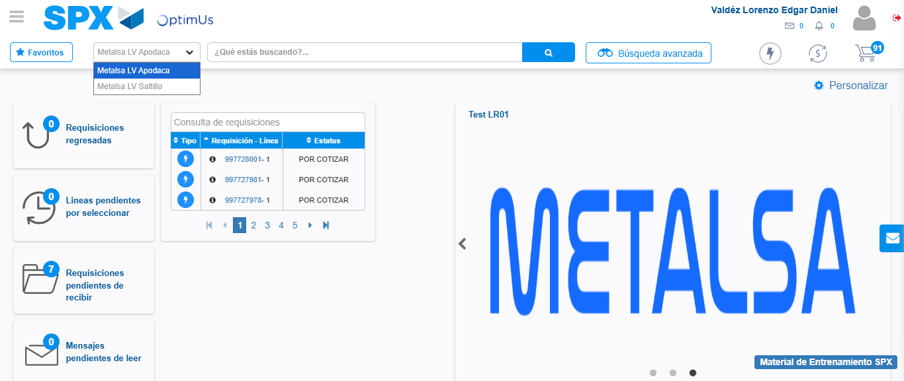Image file-name: QC_Testing-tc001_SPX_Dev5_Crear_Nueva_Linea_Requisicion_Spot_Tipo_Cobro_CC-1781565721342

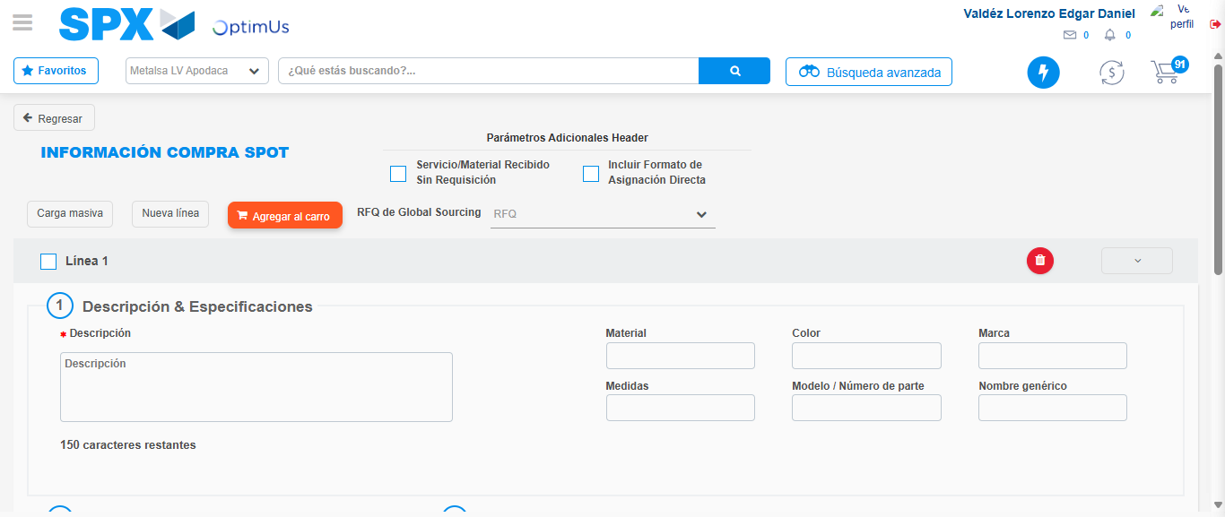Image file-name: QC_Testing-tc001_SPX_Dev5_Crear_Nueva_Linea_Requisicion_Spot_Tipo_Cobro_CC-1781565730492

Step 3 - Data Capture Spot Buy Requisition: Data captured correctly
Image file-name: QC_Testing-tc001_SPX_Dev5_Crear_Nueva_Linea_Requisicion_Spot_Tipo_Cobro_CC-1781565730831

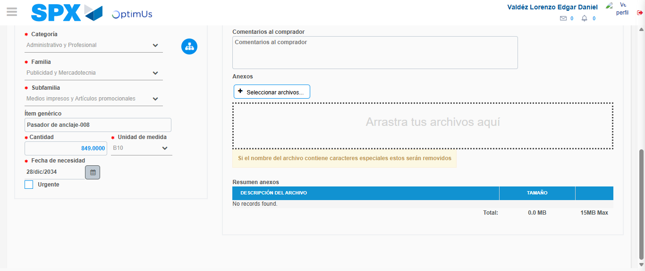Image file-name: QC_Testing-tc001_SPX_Dev5_Crear_Nueva_Linea_Requisicion_Spot_Tipo_Cobro_CC-1781565743990

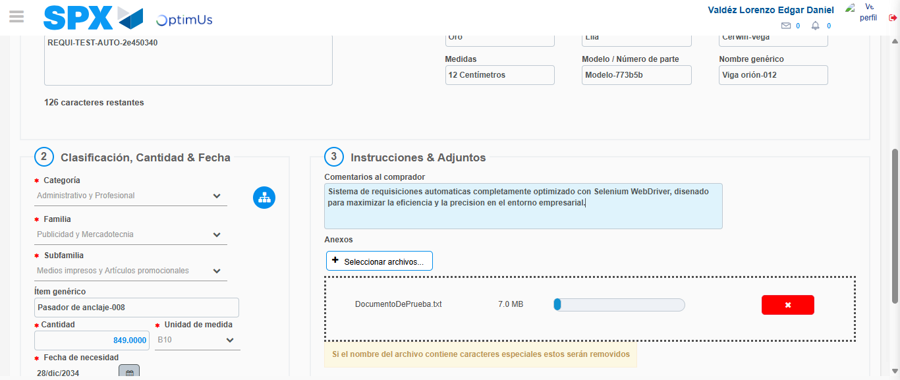Image file-name: QC_Testing-tc001_SPX_Dev5_Crear_Nueva_Linea_Requisicion_Spot_Tipo_Cobro_CC-1781565744782

Step 4 - Add new line and data capture second line: Line add correctly
Image file-name: QC_Testing-tc001_SPX_Dev5_Crear_Nueva_Linea_Requisicion_Spot_Tipo_Cobro_CC-1781565730831

Image file-name: QC_Testing-tc001_SPX_Dev5_Crear_Nueva_Linea_Requisicion_Spot_Tipo_Cobro_CC-1781565743990

Image file-name: QC_Testing-tc001_SPX_Dev5_Crear_Nueva_Linea_Requisicion_Spot_Tipo_Cobro_CC-1781565744782

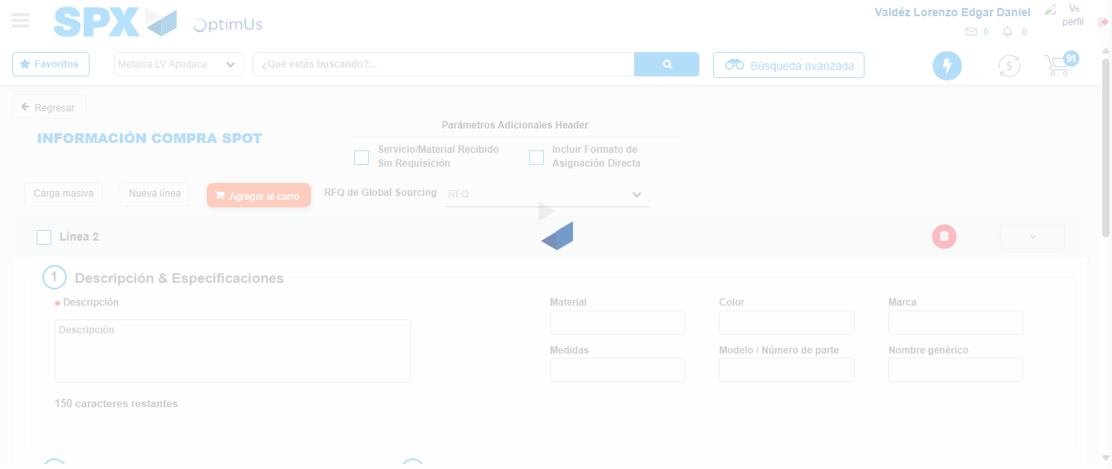Image file-name: QC_Testing-tc001_SPX_Dev5_Crear_Nueva_Linea_Requisicion_Spot_Tipo_Cobro_CC-1781565747134

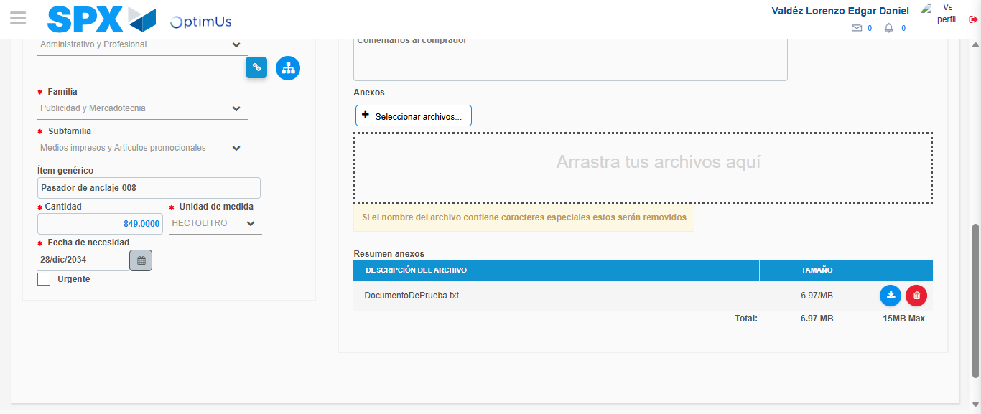Image file-name: QC_Testing-tc001_SPX_Dev5_Crear_Nueva_Linea_Requisicion_Spot_Tipo_Cobro_CC-1781565758568

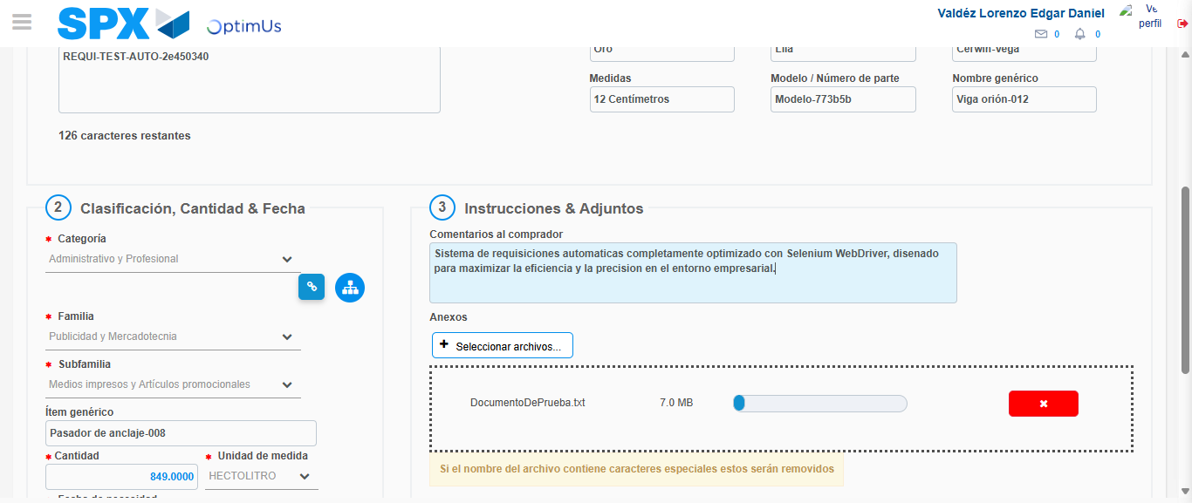Image file-name: QC_Testing-tc001_SPX_Dev5_Crear_Nueva_Linea_Requisicion_Spot_Tipo_Cobro_CC-1781565759322

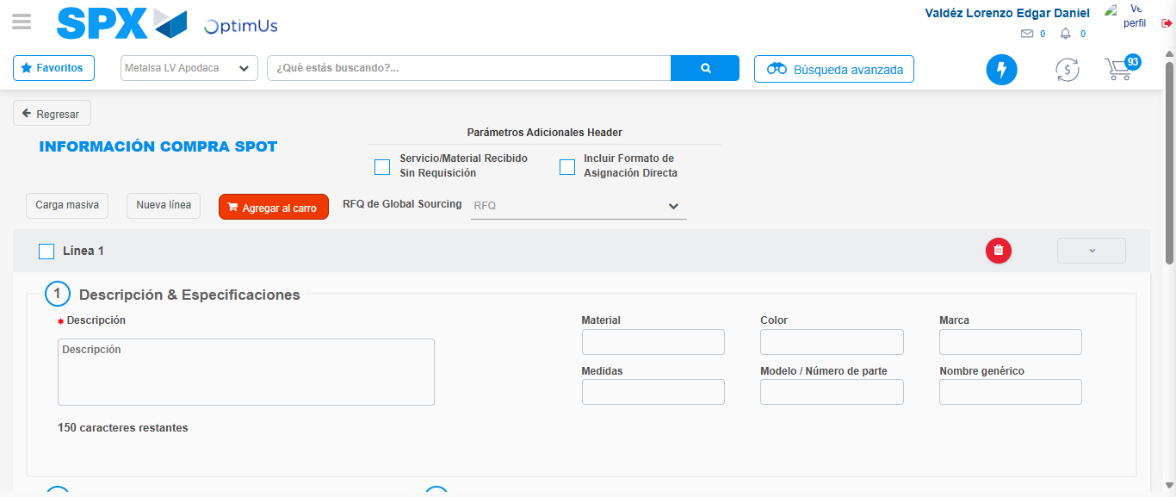Image file-name: QC_Testing-tc001_SPX_Dev5_Crear_Nueva_Linea_Requisicion_Spot_Tipo_Cobro_CC-1781565772156

Step 5 - Select to Requisition: Requisition Correctly selected
Image file-name: QC_Testing-tc001_SPX_Dev5_Crear_Nueva_Linea_Requisicion_Spot_Tipo_Cobro_CC-1781565772350

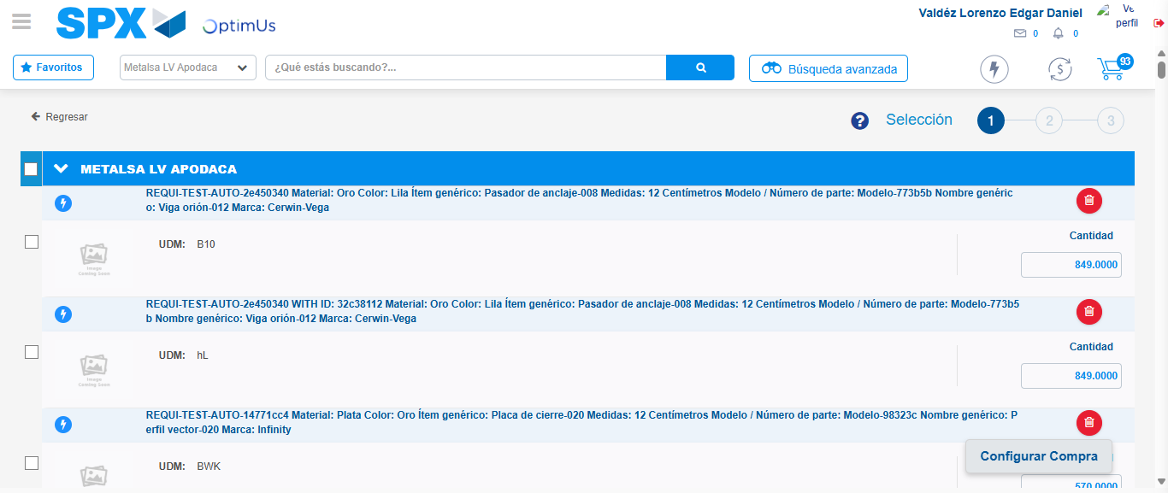Image file-name: QC_Testing-tc001_SPX_Dev5_Crear_Nueva_Linea_Requisicion_Spot_Tipo_Cobro_CC-1781565780742

Image file-name: QC_Testing-tc001_SPX_Dev5_Crear_Nueva_Linea_Requisicion_Spot_Tipo_Cobro_CC-1781565780978

Image file-name: QC_Testing-tc001_SPX_Dev5_Crear_Nueva_Linea_Requisicion_Spot_Tipo_Cobro_CC-1781565781177

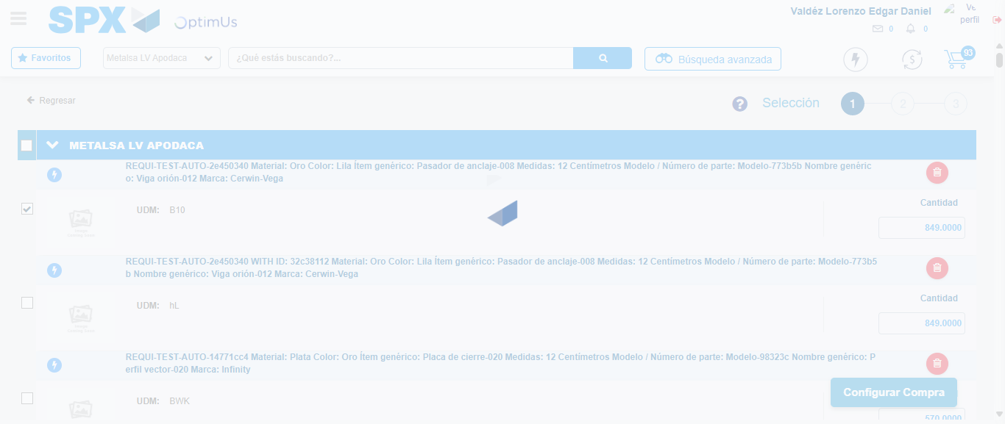Image file-name: QC_Testing-tc001_SPX_Dev5_Crear_Nueva_Linea_Requisicion_Spot_Tipo_Cobro_CC-1781565782041

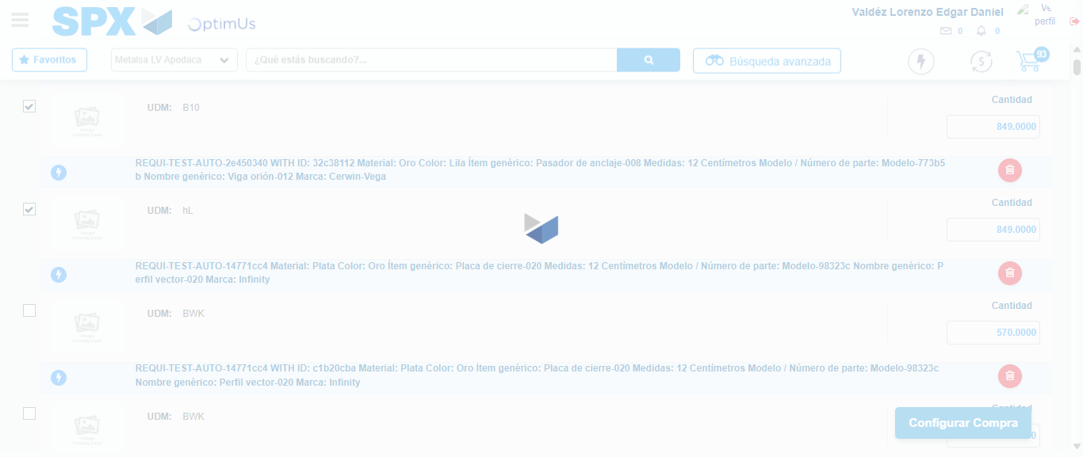Image file-name: QC_Testing-tc001_SPX_Dev5_Crear_Nueva_Linea_Requisicion_Spot_Tipo_Cobro_CC-1781565782924

Step 6 - Select Type Account For Requisition: Type Account Correctly selected
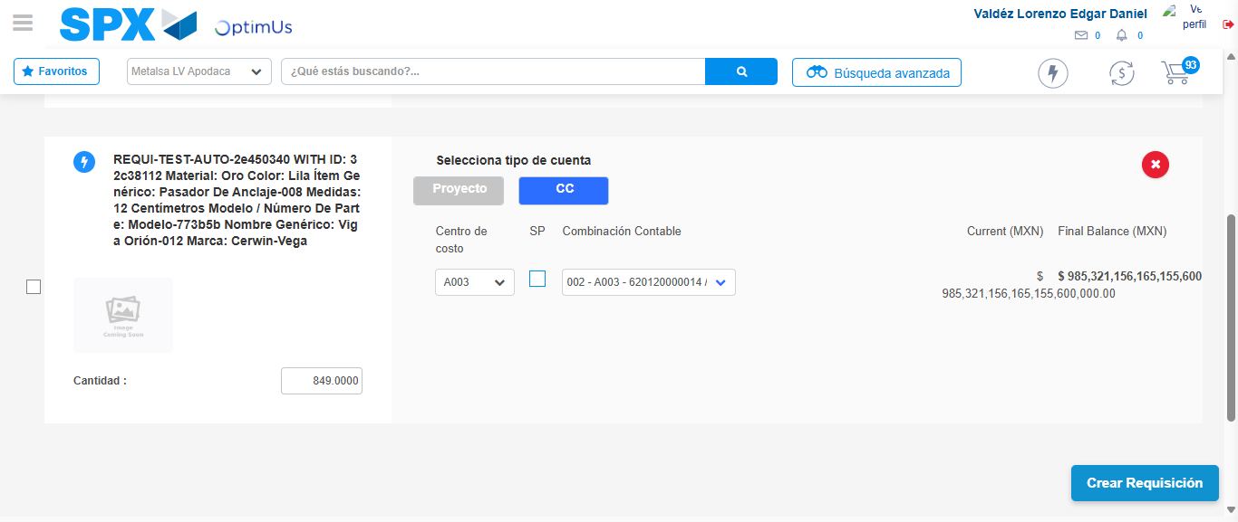Image file-name: QC_Testing-tc001_SPX_Dev5_Crear_Nueva_Linea_Requisicion_Spot_Tipo_Cobro_CC-1781565852008

Image file-name: QC_Testing-tc001_SPX_Dev5_Crear_Nueva_Linea_Requisicion_Spot_Tipo_Cobro_CC-1781565852216

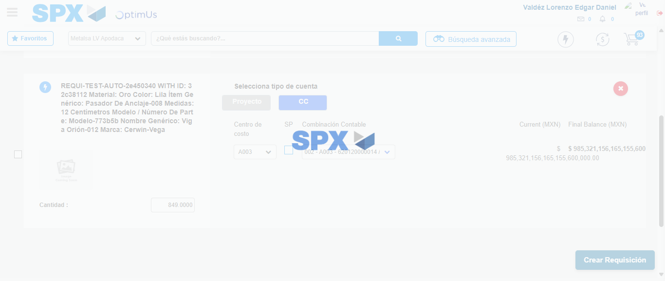Image file-name: QC_Testing-tc001_SPX_Dev5_Crear_Nueva_Linea_Requisicion_Spot_Tipo_Cobro_CC-1781565852560

Step 7 - Accept to Requisition: Requisition Accepted
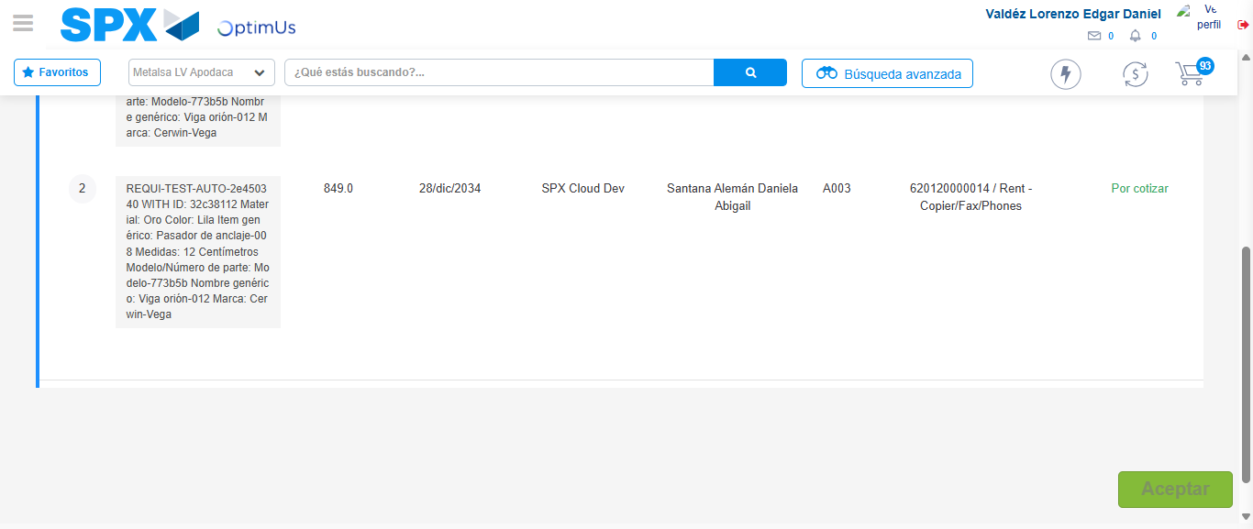Image file-name: QC_Testing-tc001_SPX_Dev5_Crear_Nueva_Linea_Requisicion_Spot_Tipo_Cobro_CC-1781565853383

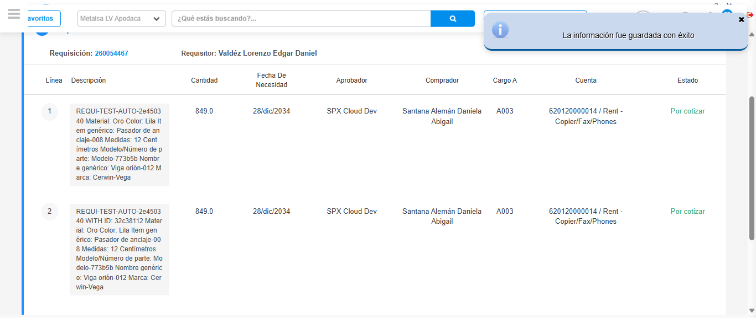Image file-name: QC_Testing-tc001_SPX_Dev5_Crear_Nueva_Linea_Requisicion_Spot_Tipo_Cobro_CC-1781565855848

Step 8 - Return to Main Page SPX : Return to Main Page SPX
Image file-name: QC_Testing-tc001_SPX_Dev5_Crear_Nueva_Linea_Requisicion_Spot_Tipo_Cobro_CC-1781565718483

Image file-name: QC_Testing-tc001_SPX_Dev5_Crear_Nueva_Linea_Requisicion_Spot_Tipo_Cobro_CC-1781565721342

Image file-name: QC_Testing-tc001_SPX_Dev5_Crear_Nueva_Linea_Requisicion_Spot_Tipo_Cobro_CC-1781565730492

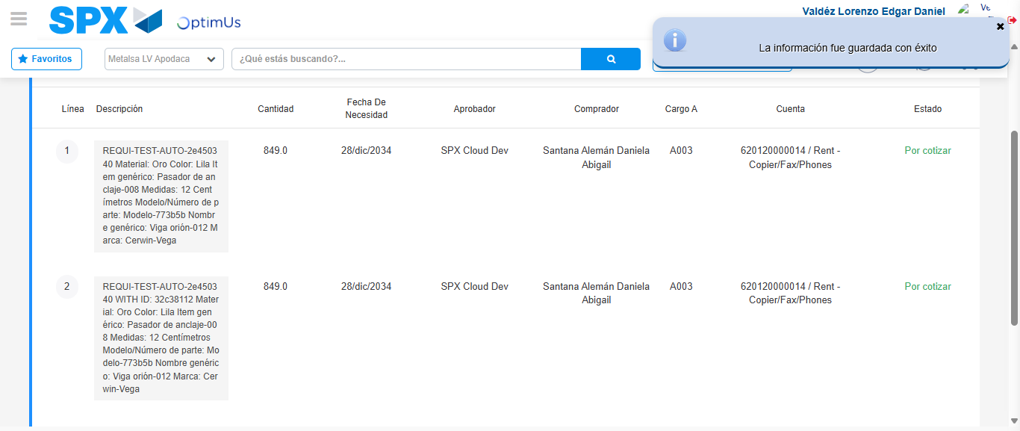Image file-name: QC_Testing-tc001_SPX_Dev5_Crear_Nueva_Linea_Requisicion_Spot_Tipo_Cobro_CC-1781565858080

Image file-name: QC_Testing-tc001_SPX_Dev5_Crear_Nueva_Linea_Requisicion_Spot_Tipo_Cobro_CC-1781565858257

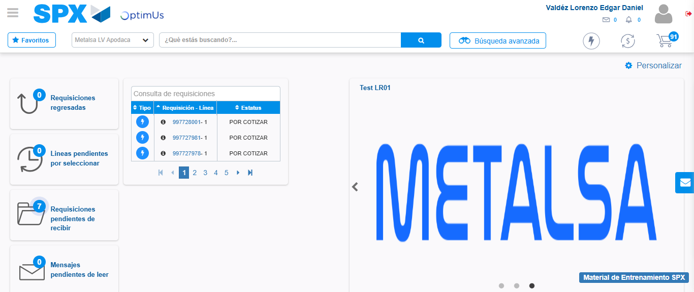Image file-name: QC_Testing-tc001_SPX_Dev5_Crear_Nueva_Linea_Requisicion_Spot_Tipo_Cobro_CC-1781565879299

Step 9 - Log Out : Log Out SPX
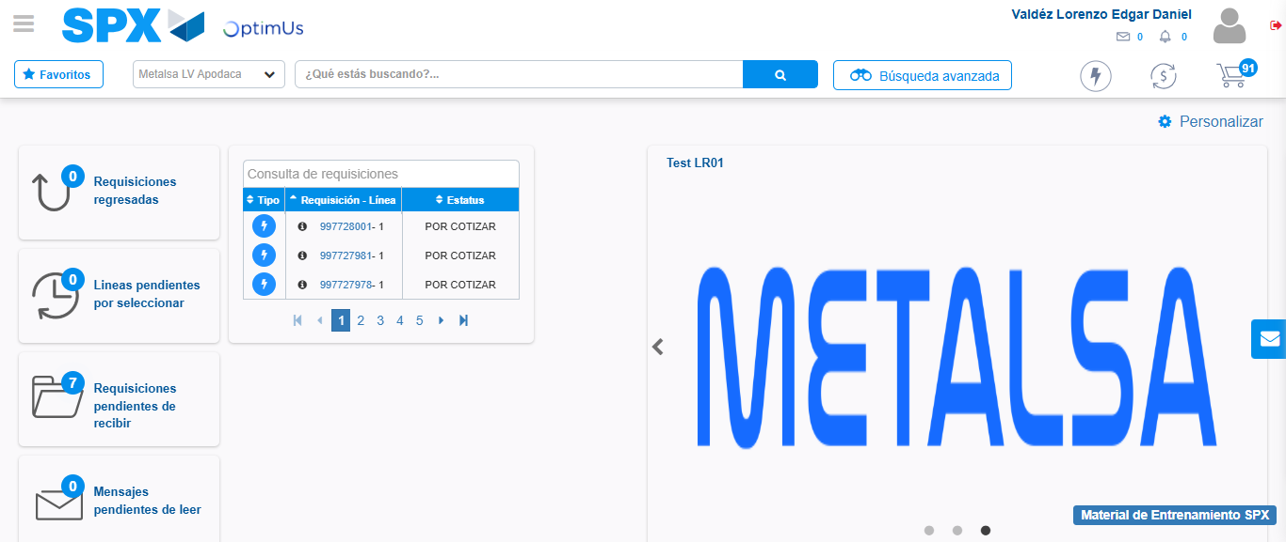Image file-name: QC_Testing-tc001_SPX_Dev5_Crear_Nueva_Linea_Requisicion_Spot_Tipo_Cobro_CC-1781565879562

